# Data Centric RAD

## **Revision Lab – SQL Explorer**

SQL Explorer is a graphical interface alternative to the MySQL Console.

If you want to use it on the lab PCs follow Part 2 and Part 3 only.

If you want to install it on your own laptop follow Part 1, Part 2 and Part 3.

### Part 1 – Download SQL Explorer

1. Goto <https://sourceforge.net/projects/eclipsesql/files/> and download the latest version of SQL Explorer:

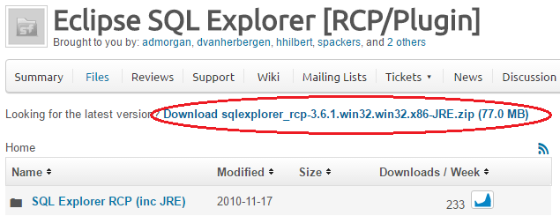

1. Extract the zip file.
2. To Run double click SQLExplorer\sqlexplorer.exe in folder just extracted.

### Part 2 – MySQL Connector/J

1. Goto <https://dev.mysql.com/downloads/connector/j/5.1.html> and download MySQL Connector/J:

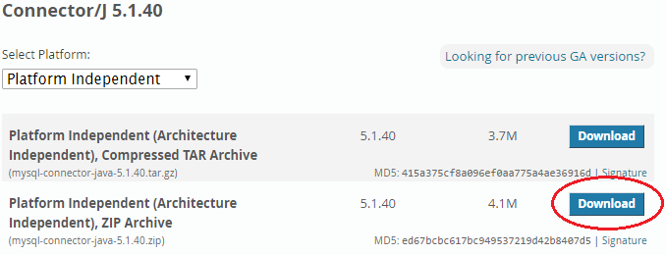

1. Extract the zip file just downloaded.

### Part 3 – SQL Explorer – Add MySQL Connector/J

1. Open SQL Explorer by clicking on the SQLexplorer icon on the desktop:

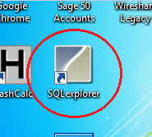

1. In SQL Explorer, select *File/Preferences*/*SQL Explorer/JDBC Drivers*.
2. Click on *MySQL Driver* and press *Edit*.
3. Click on *Extra Class Path*, then *Add JARs…* then select the MySQL Connector/J jar file and press *Open*.
4. Click *List Drivers*.
5. In the *Driver Class Name* box select *com.mysql.jdbc.Driver* as shown and press *OK*.

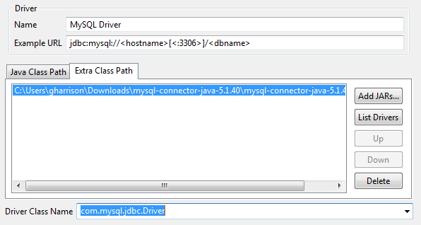

1. Press *Set Default*, then press *OK*.

### Part 3 – SQL Explorer – Create connection to DB

Continue from this point

1. Click the *Create New Connection Profile* icon as shown:

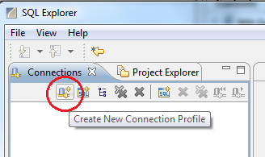

1. Fill in the New Connection profile by specifying the following values and pressing *OK*.

*Name* – Any String

*Driver* – The Driver created earlier

*URL* –

<hostname> - localhost

<dbname> - name of database to connect to **This database must exist in MySQL**

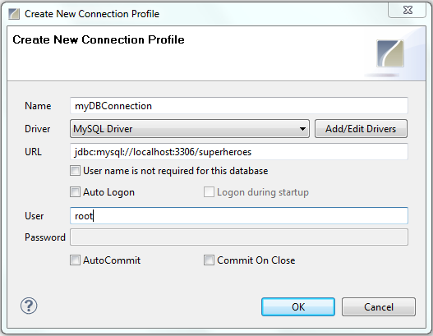

1. Ensure WAMP/MySQL is started.
2. Double-click on *root* and press *OK*, then select one of the connections to type SQL commands.

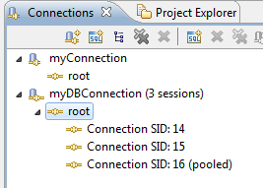

1. Type in SQL commands as normal and select the *Execute SQL* icon as shown.

The output from large tables can be seen more conveniently than in the MySQL command console.